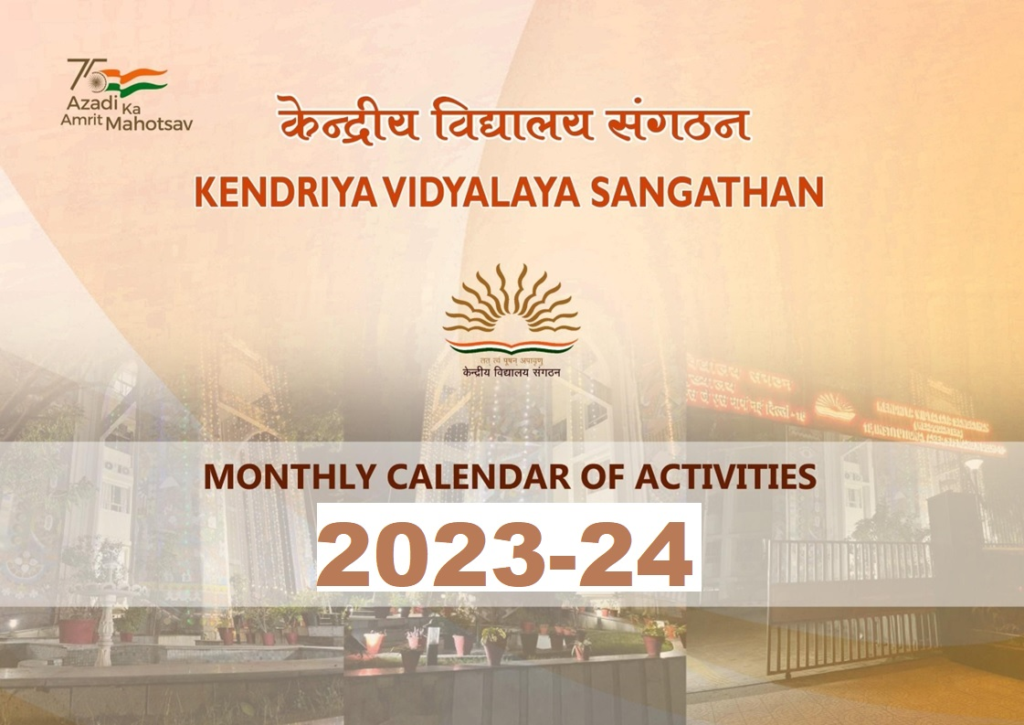

Page 1 of 12

|  |  |
| --- | --- |
| Areas | Activities |
| Academic | * Art Integrated Project to students during Summer Vacation * Vidya Pravesh for Class I Students * Assignment of Homework in multidisciplinary project. |
| Examination | * Review of Class IX &XI results 2021- 22 |
| Celebration of National/International Event/Week | * Green School Contest * Intel-ATLInnovation Competition |
| Affiliation/ Maintenance / Repair others | * Review of Maintenance & Repair Works of School Buildings & Submission of Financial Estimate for M & R Works to KVS HQs through RO. * Review of facilities like Water Supply, Power Supply & Internet   facilities in KV. |
| Ek Bharat Shrestha Bharat | Making Videos of 100 sentences learnt in the language of Paired State & Sing Songs of Paired State |
| Azadi Ka Amrit Mahotsav | Collection of Patriotic Songs, Paintings, Slogans and News used by the local freedom fighters & Unsung Heroes during the freedom struggle of India |

|  |  |
| --- | --- |
| Areas | Activities |
| Promotion of Science & Technology and Mathematics | * Participation of students in different webinar conducted by CSIR/ISRO/ Department of Science of Technology etc. * SAKURA exchange. |
| Games & Sports & Others | Vidyalaya Level Sports Competition |
| Scouts and Guides | - |

|  |  |
| --- | --- |
| Areas | Activities |
| Academic | Vidya Pravesh for Class I Students |
| Examination | - |
| Celebration of National/International Event/Week | * Celebration of International Yoga Day. * World Environment Day |
| Affiliation/ Maintenance / Repair others | * Review of Maintenance & Repair Works of School Buildings & Submission of Financial Estimate for M & R Works to KVS HQs through RO. * Review of facilities like Water Supply , Power Supply & Internet   facilities |
| Ek Bharat Shrestha Bharat | Showing & Reviewing of popular films in the language of paired state  (Review of films will be written either in Hindi or English). |
| Azadi Ka Amrit Mahotsav | * Preparation of Scrap Book on Dandi March, National Song, National Anthem & Making of Constitution of India. * Conduct of lectures, Seminars, Expert Talk on Yoga & Mediation in KVs. |

|  |  |
| --- | --- |
| Areas | Activities |
| Promotion of Science & Technology and Mathematics | School Level competition for Science & Technology, Mathematics in KVS. |
| Games & Sports & Others | Vidyalaya Level Sports Competition, Seema Darshan |
| Scouts and Guides | Registration of the students in the BS&G Unit. |

|  |  |
| --- | --- |
| Areas | Activities |
| Academic | * Registration & Admission in Class-XI (After declaration of CBSE Results ) * Publication of Vidyalaya Patrika . * NIPUN meeting * Vidya Pravesh for Class - I students |
| Examination | * Periodic Test- I for Class III to X * Monthly Test for Class XII |
| Celebration of National/International Event/Week | Van Mahotsav |
| Affiliation/ Maintenance / Repair others | * Review of Maintenance & Repair Works of School Buildings & Submission of Financial Estimate for M & R Works to KVS (HQs) through RO. * Review of facilities like Water   Supply, Power Supply & Internet facilities. |
| Ek Bharat Shrestha Bharat | * Completion of leaning 100 sentences of language of paired state. * Writing of 100 sentences learnt in the language of paired state. |
| Azadi Ka Amrit Mahotsav | * Educational Tour to the local sites of Historical importance/ Museums   / Places related with freedom struggle of India, Experience Sharing on the visit.   * How to eliminate Single Use Plastic   - campaign both inside and outside of the school and use social medial handles to create awareness." |

|  |  |
| --- | --- |
| Areas | Activities |
| Promotion of Science & Technology and Mathematics | * IOQM/JIGYASA * Review of Atal Tinkering Lab (ATL) & Science Lab activities |
| Games & Sports & Others | Vidyalaya Level Sports Competition, |
| Scouts and Guides | Tritiya Sopan Testing Camp of Scouts and Guides at Regional Level. |

|  |  |
| --- | --- |
| Areas | Activities |
| Academic | * Constitution of Student Council / Investiture Ceremony * Review of Language Lab activities |
| Examination | - |
| Celebration of National/International Event/Week | * Youth Parliament at RO level. * Celebration of Independence Day * Celebration of Sanskrit Week |
| Affiliation/ Maintenance / Repair others | Submission of List of Candidates (LOC)to CBSE for Class X & XII (Tentative) |
| Ek Bharat Shrestha Bharat | Cultural Competition- Folk dance/ patriotic song & music of the Paired state for classes I-XII. |
| Azadi Ka Amrit Mahotsav | * Reliving the struggle for Independence through community singing/ Fancy Dress Competition/ Prabhat Pheri etc. * Writing about 75 Unsung Heroes of India’s Independence, 75 Known Places of India’s Independence, 75 Events of Indian Independence." |

|  |  |
| --- | --- |
| Areas | Activities |
| Promotion of Science & Technology and Mathematics | INSPIRE Awards MANAK Scheme |
| Games & Sports & Others | * Celebration of National Sports Day * Medical Health Checkup * Regional Level Sports Meet |
| Scouts and Guides | Rajya Puraskar Testing Camp of Scouts and Guides. |

|  |  |
| --- | --- |
| Areas | Activities |
| Academic | * Submission of Staff Sanction proposals for Academic Session 2023-24 * Review of Action Taken of Academic Supervision & Plan of Action thereof. |
| Examination | * Half Yearly Examination for Class III to VIII * Periodic Test-I for Class-XI * Periodic Test-II for Class-IX & X * Monthly Test for Class XII |
| Celebration of National/International Event/Week | Celebration of Teachers’ Day/ Hindi Diwas & Hindi Pakhawada |
| Affiliation/ Maintenance / Repair others | Online CBSE Registration of Class IX & XI (Tentative) |
| Ek Bharat Shrestha Bharat | Video Conferencing with students of Paired State for Classes VI-XII. |
| Azadi Ka Amrit Mahotsav | Sketch Drawing and Explanation content on historical events  /Incidents of India’s freedom Struggle |

|  |  |
| --- | --- |
| Areas | Activities |
| Promotion of Science & Technology and Mathematics | INSPIRE Awards MANAK- District Level (Tentative) |
| Games & Sports & Others | * KVS National Sports Meet for Boys & Girls * Participation in National School Games Khelo India * Activities under NCC |
| Scouts and Guides | Golden Arrow Award Camp of Cub/ Bulbul at Regional Level / Celebration  of International Day of Peace on 21st September |

|  |  |
| --- | --- |
| Areas | Activities |
| Academic | * Distribution of Students Support Material for the Class X & XII students * 3rd NIPUN meeting |
| Examination | 1st Pre-Board Examination for class X & class XII (Winter Station KVs) |
| Celebration of National/International Event/Week | * Celebration of Gandhi Jayanti * National Unity Day * Vigilance Awareness Week |
| Affiliation/ Maintenance / Repair others | Review of upkeep of School buildings & playground. |
| Ek Bharat Shrestha Bharat | Exhibition on Art, Paintings, Cuisines, scriptures. Monuments of paired State |
| Azadi Ka Amrit Mahotsav | * Speech Competition on ‘How to preserve and nurture India’s Independence’ * Showcasing of Video on Sardar Vallabhbhai Patel to students on National Unity Day. * Draw Portraits/ Bust of Sardar Vallabhbhai Patel & activities related to INA Raising Day" |

|  |  |
| --- | --- |
| Areas | Activities |
| Promotion of Science & Technology and Mathematics | Conduct of National Children Science Congress at Vidyalaya & RO level |
| Games & Sports & Others | * KVS National Sports Meet for Boys & Girls * Participation in National School Games Khelo India * Activities under NCC |
| Scouts and Guides | Regulars Scout and Guides activities |

|  |  |
| --- | --- |
| Areas | Activities |
| Academic | Review of Subject Committee Meetings at School Level & Action Taken thereof |
| Examination | * Periodic Test- II for Class- III to VIII * Half Yearly Examination for Class XI * 1st Pre Board Examination for Class   X & XII (Summer Station KVs) |
| Celebration of National/International Event/Week | * Youth Parliament at Zonal Level * Celebration of Children’s Day * National Education Day * Constitution Day * Communal Harmony Week |
| Affiliation/ Maintenance / Repair others | - |
| Ek Bharat Shrestha Bharat | Speech/Debate/Essay/Quiz on Fundamental Rights & Duties/ Preamble of Constitution of India. |
| Azadi Ka Amrit Mahotsav | * Writing letters/Design Greeting Cards by the students to the families of the freedom fighters/ Unsung Heroes of the state/ district concerned. * Let me know “Constitution of India”, Preparing questions by students on Rights & Duties of Indian Citizen, Preamble of Constitution of India & Panchayat   Raj System " |

|  |  |
| --- | --- |
| Areas | Activities |
| Promotion of Science & Technology and Mathematics | * JNNSMEE * National Children Science Congress (NCSC) |
| Games & Sports & Others | * Sports Day Celebration Participation in National School Games * Khelo India Tournament through States |
| Scouts and Guides | Celebration of Bharat Scouts & Guides Foundation Day / Flag Day on 7th November. |

|  |  |
| --- | --- |
| Areas | Activities |
| Academic | * Strategy for focused Revision and follow up after of Pre Board Examination. * Special Classes for Class- X & XII * Career Counseling Programme for Classes IX to XII by inviting experts, Scientist & Guest Speakers/Artists etc. |
| Examination | - |
| Celebration of National/International Event/Week | Annual Day/Grand Parents Day / KVS Foundation Day / National Mathematics Day |
| Affiliation/ Maintenance / Repair others | - |
| Ek Bharat Shrestha Bharat | * State Project Note Book/ Scrap Book of Paired State for classes VI- X, Digital photo collage making on paired state. * Student Exchange Programmewith Paired State |
| Azadi Ka Amrit Mahotsav | Role Play by Students about freedom fighters & Unsung Heroes. |

|  |  |
| --- | --- |
| Areas | Activities |
| Promotion of Science & Technology and Mathematics | INSPIRE Awards MANAK - National Level (as per schedule notified by Department of Science Technology) |
| Games & Sports & Others | * Participation in National School Games & Khelo India tournament through states * Seema Darshan |
| Scouts and Guides | State Level President (S/G) Certificate Examination Testing Camp. |

|  |  |
| --- | --- |
| Areas | Activities |
| Academic | * 4th NIPUN Meeting * Review all Academic Committees |
| Examination | * 2nd Pre Board Examination for Class X & XII (marks of Pre Board to will be treated as marks for Periodic Test- III for Class-X) for preparation result. * Periodic Test-III for Class IX * Periodic Test-II for Class XI |
| Celebration of National/International Event/Week | * Celebration of Republic Day * National Youth Day |
| Affiliation/ Maintenance / Repair others | Preparation of Panel for Contractual Teachers for 2023-24 |
| Ek Bharat Shrestha Bharat | Preparation of Art Project for School level Internal Assessment for 2022 Exam. |
| Azadi Ka Amrit Mahotsav | Let me know Netaji and his unparalleled contribution to India’s Freedom struggle. (Write Stories, Slogan, Poems on Freedom Struggle) |

|  |  |
| --- | --- |
| Areas | Activities |
| Promotion of Science & Technology and Mathematics | National Children Science Congress (As per direction of Department of Science & Technology) |
| Games & Sports & Others | Medical Health Checkup |
| Scouts and Guides | State Level President (S/G) Certificate Examination Testing Camp. |

|  |  |
| --- | --- |
| Areas | Activities |
| Academic | * Notification and Registration for Admission in Class- I, Academic session 2023-24 * Revision work for Session Ending Examination |
| Examination | Practical’s for Class IX to XII |
| Celebration of National/International Event/Week | * National Science Day * InternationalMother Language Day |
| Affiliation/ Maintenance / Repair others | Preparation of Panel for Contractual Teachers for 2023-24 |
| Ek Bharat Shrestha Bharat | School Report Patrika (e-Magazine) for Annual Activities of EBSB. |
| Azadi Ka Amrit Mahotsav | How can I contribute for building a Nation’s Vision? |

|  |  |
| --- | --- |
| Areas | Activities |
| Promotion of Science & Technology and Mathematics | Review of ATL Activities |
| Games & Sports & Others | Preparation & Planning for Games &Sports for next Academic Session |
| Scouts and Guides | Celebration of Bharat Scouts and Guides Founder’s Day / World Thinking Day on 22nd February. |

|  |  |
| --- | --- |
| Areas | Activities |
| Academic | * Admission to Class -I, session- 2023- 24 * Printing of students' Diaries & Teachers' Diaries for Academic session * Framing of Time Table for next Academic year * Planning for new Academic session   2023-24 |
| Examination | Annual Examination- 2022-23 Declaration of Results |
| Celebration of National/International Event/Week | - |
| Affiliation/ Maintenance / Repair others | - |
| Ek Bharat Shrestha Bharat | - |
| Azadi Ka Amrit Mahotsav | - |

|  |  |
| --- | --- |
| Areas | Activities |
| Promotion of Science & Technology and Mathematics | - |
| Games & Sports & Others | - |
| Scouts and Guides | - |